**UNIVERSITY OF DAR ES SALAAM**

**COLLEGE OF INFORMAT****ION AND COMMUNICATIONS TECHNOLOGIES (COICT)**

**DEPARTMENT OF ELECTRONICS AND TELECOMMUNICATIONS ENGINEERING**

**TE371: INTRODUCTION TO RESEARCH METHODOLOGIES**

**PROJECT PROPOSAL**

**TITLE: “SMART AND SECURE HOMES: IoT Approach To Improve Security”**

**PARTICIPANTS**

|  |  |  |  |
| --- | --- | --- | --- |
| **S/N** | **Name** | **Registration Number** | **Course** |
| 1 | VINTAN, ALPHA | 2020-04-12324 | BSc EE |
| 2 | WILFRED, NANCY | 2020-04-12414 | BSc TE |
| 3 | MKINGILIMA, AGAPITY | 2020-04-07207 | BSc EE |
| 4 | KOWERO, WALIDI WAZIRI | 2020-04-04390 | BSc EE |
| 5 | TEGAMBWAGE, MWESIGA N | 2020-04-12061 | BSc TE |

**INSTRUCTOR: Dr.** FLORIAN MKEMWA

**DATE OF SUBMISSION:** May 25, 2023

**Chapter One**

**PROBLEM ANALYSIS.**

**1.1 INTRODUCTION**

Internet of Things (IoT) refers to a network of interconnected physical devices, vehicles, appliances, and other objects embedded with sensors, software, and connectivity capabilities that enable them to collect and exchange data between several gadgets connected to a single network where they may be easily controlled and monitored.

As security is the term which has the most significance in today’s era, technology has been offering solutions for any kind of prevention in almost every domain such as banking, Cyber security, home security, business security and problems alike.

Most traditional home security systems are usually made of sensors mounted on doors, walls, and windows with features like alarms or home monitoring mainly focused on perimeter of home characterized with pretty hard installation, use and quite impossible to real-time monitoring.

Thus, smart homes utilizing IoT environment has made one-step further movement in the way of pervasive connectivity to homes, and society to transform the whole outlook on foreseeing, monitoring different phenomena and processes against intrusion or abduction.

Smart home is a section of the IoT that aims to integrate home automation and security. Enabling objects in a typical household to be connected to the Internet allows home-owners to remotely monitor and control them but mostly do not implement intruder detection before they enter the house.

This study project aims to combat house break-ins and theft of household objects in our society by presenting a low cost-architecture (affordable), easy integrable, and security efficient system using IoT approach to provide confidence and peace of people and their properties.

**1.2 PROBLEM STATEMENT**

Smart Homes and Intelligent Buildings are characterized by ubiquitous services and effective decision making with enhanced accuracy. Designing smart security solutions for detecting intruders way before damage has been done, has always been a challenging aspect for researchers.

According to the Tanzania Victimization Survey Executive Summary, a substantial number of reported crimes consisted of household crimes, accounting for 70.3% of the total crimes reported. These crimes occurrences occur predominantly in defenseless constructions that rely on traditional security systems which often prove *inefficient in detecting intruders* before they enter the house.

This inefficiency instills fear in homeowners, even when they are away for extended periods, as significant damage can be done before law enforcement or security companies can respond effectively.

Hence, there is a critical need to develop an automated and real-time surveillance system for home security, addressing the limitations of traditional security systems in providing early warning and alert signals, capture images, and transmit data directly to a server for remote instructions from users.

By leveraging the capabilities of IoT technology, our solution aims to enhance the effectiveness of home security systems, enabling homeowners to maintain peace of mind and enjoy the tranquility of their homes without fear of intrusion. Thus, empowering homeowners to protect their properties, even in their absence, and minimize the potential damage that can occur before law enforcement or security companies can respond adequately.

**1.3 OBJECTIVES**

**1.3.1 MAIN OBJECTIVES**

The main objective of this research is to *design a smart and secure home system* using an IoT approach to *detect* and *prevent household crimes.*

**1.3.2 SPECIFIC OBJECTIVES.**

The study follows the following objectives:

* Studying performance limiting factors that hinder the efficiency of smart home systems in security aspects.
* Design an architecture that provides real time monitoring of household activities.
* Design mechanisms to secure entry points, activate alarms, or control access to different areas of the smart home system.
* Implement a user-friendly interface on the server side that enables homeowners to monitor the security aspects of their smart home system

**1.4 SIGNIFICANCE OF THE PROJECT**

The following are the expected benefits of the project;

1. Reduce fear to home-owner: With this system, home-owners can now focus solely in production activities with an ease mind, since they can monitor their homes by a click of the finger.
2. Freedom of participation: People can freely participate in society activities and reallocation of resources due to an improved security.

**1.5 SCOPE**

The project aimed at dealing with a;

* Middle Class Society focused in Dar es Salaam.
* Developing Country
* Main focus or priority is on system efficiency over cost

**Chapter Two**

**LITERATURE REVIEW**

This chapter reviews prior works on IoT-enabled home security systems, with a focus on utilizing low-cost open-source hardware components. The aim is to provide an overview of the factors influencing the functioning and security of these systems. An electronic literature search was conducted to identify relevant resources for review, considering publications from 2008 to 2018 and accessing online resources.

One study byS. Tanwar et al (2017)described a home security system that implemented a real-time email alert system. It utilized security cameras and PIR (Passive Infrared) sensors connected to a Raspberry Pi via USB ports and general-purpose input/output pins. The system detected motion by comparing inputs from the PIR sensors with previous readings. When a difference was detected, the security camera captured an image, which was temporarily stored on the Raspberry Pi and then emailed to the resident.

In a different study by P. Netinant et al (2022) offered a prototype for an Internet of Things-based home intruder detection system using Passive Infrared Motion Detector based on Internet of Things. They also examined several choices for each attribute, including aspects of passive infrared motion detector works that suggest unique methods for home invader motion detectors on the Internet of Things. The system can also do daily motion detection work automatically by providing intruder detection in a variety of distances and angles of circumstances and location monitoring.

In contrast, M. ShariqSuhaill et al (2016)implemented a prototype for a smart home security system using PIR sensors for detecting smoke and gas leaks. The system also utilized temperature sensors, a buzzer, an LCD, LED strips, and a GSM module for SMS notifications and calls. Outputs from an Arduino Mega 2560 board were used, and a Raspberry Pi 2 board incorporated a webcam that captured images upon motion detection.

Through a careful analysis of these prior research works, this literature review reveals certain weaknesses in current smart home systems. The reliance on email notifications for system alerts often leads to delays in timely notifications to homeowners. Moreover, these systems have demonstrated limitations in effectively detecting criminal break-ins before significant damage occurs.

By analyzing the literature on IoT-enabled home security systems, this review identified gaps and areas for improvement. These insights will guide the current study in developing an enhanced smart and secure home system.

**Chapter Three**

**PRELIMINARY DESIGN**

**3.1 REQUIREMENT SPECIFICATIONS**

Outlines in detail the behaviors, function[,](https://www.jamasoftware.com/requirements-management/functional-requirement-vs-non-functional-requirements/) and capabilities required of the system, along with any potential constraints. In this chapter both marketing and engineering requirements are included.

**3.1.1 MARKETING REQUIREMENTS**

The requirements that should satisfy a home-owner while using this system are: -

1. Early warnings and alerts
2. Interoperable to different levels of security
3. Real time monitoring of home situations
4. Easy installation
5. Affordable cost-architecture
6. Operating even in absence of electricity

**3.1.2 ENGINEERING REQUIREMENTS**

To understand the Engineering requirements, they were mapped to user requirements and provided with justification to support the grounding theory as follows:

***Table 3.1: Engineering Requirements with Justification***

**3.2 SYSTEM ARCHITECTURE**

The system architecture in this study involved the following multiple layers to build an extensive and interconnected ecosystem that provides the security, comfort, and peace of mind for homes:

1. **Sensing Layer**: Consists of various sensors that are placed strategically throughout the house to detect and gather information about security-related factors like motion, door/window status, and video surveillance, the basis for system decision-making.
2. **Control Layer:** This layer is in charge of carrying out operations by regulating the operation of numerous devices and subsystems to react to security occurrences. Provides direct communication link between communication and sensing layers.
3. **Communication Layer:** Enables the interchange of data between various smart home security system components and subsystems. To allow smooth connectivity and information flow, it uses wired and wireless communication protocols.
4. **User Interface Layer:** Gives homeowners the tools to communicate with their smart home security system. Homeowners may remotely manage devices, get alerts, change security settings, and monitor the security status of their houses wherever they are.

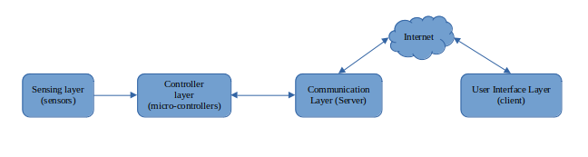***Figure 3.2: Smart Home Security System Architecture***

**3.3 TASK DIVISION**

The project Manager of this project under study divided the tasks among the team members to ensure efficient progress and successful completion of the project based on the expertise and skills of each team member, specific objectives and requirements of the project as follows:

1. Research and Analysis: In this category, three members were included to perform each task individually as follows:
   * One team member will responsible for undergoing a *critical evaluation* on whether the *problem* we want to solve has impact on the society.
   * Another team member will be responsible for conducting *in-depth research* on existing smart home security systems, IoT technologies, and intrusion detection methods.
   * Another team member will be responsible for *analyzing* necessary *requirements* for successful completion of the project.

This task will involve studying performance limiting factors, evaluating the effectiveness of different security features, and identifying potential areas of improvement.

1. System Architecture Design and Testing: In this category the remaining two participants were to perform the following tasks:
   * One team member will be assigned the task of designing and *developing the architecture* for the smart home security system as well as performing the analysis of the results if it satisfies requirements.
   * The last team member collaborating with the previous member will focus on *designing a scalable system* to enable real-time monitoring, alerts and lock-down capabilities, s*imple* and *user-friendly interface* design and testing the system using appropriate IoT devices, sensors.

By dividing the tasks in this manner, we aimed to leverage the expertise and skills of each team member while ensuring a comprehensive approach to the research and development of the smart home security systems. Regular communication and collaboration among team members will be maintained throughout the project to ensure synchronization, knowledge sharing, and timely completion of tasks.

**3.4 TASK SCHEDULING**

It is a crucial aspect of project management that involves planning and organizing activities, resources, and timelines to ensure the successful completion of a project by providing a road-map for proper allocation of resources, set priorities, and monitor progress towards project goals.

In order to establish a realistic and achievable timeline for project activities, this project is estimated to be completed within a minimum of three weeks considering constraints and resources as depicted in the figure below.

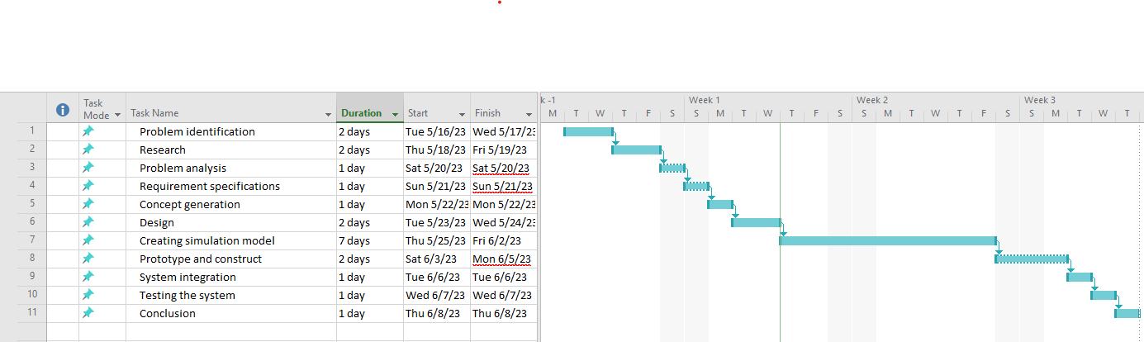

***Figure 3.3: Task Division and Time Schedule***

**Chapter Four**

**SYSTEM DESIGN**

**4.1 GENERAL INTRODUCTION**

Design is a meaningful representation of something or system to be built. It involves taking both software and hardware requirements and specifications and adding details needed for actual implementation in a computer.

**4.2 CONCEPT GENERATION AND EVALUATION**

Refers to the process of creating ideas for designing a product based on the user or target specifications and requirements. It is an important step in designing a product. It involves generating ideas for several alternative product designs and evaluation to identify the best ones.

**4.2.1 CONCEPT GENERATION**

To design home security system for intrusion detection, best meeting the user requirements multiple solutions were designed as illustrated in the *table 4.2* below.

***Table 4.1: Concept generation table***

**4.2.2 CONCEPT EVALUATION**

Decision Matrix was used to evaluate and prioritize a list of options by establishing a list of weighted criteria and then evaluate each option against those criteria. The main role is to narrow down the list of options to one choice that abide by the scope of this project.

Rating scale employed in the decision matrix for each criterion are:

* 1 – slight extent, 2 – some extent, 3 – great extent

***Table 4.2: Decision Matrix for different solutions for Micro-controllers and sensors***

***Table 4.2: Decision Matrix for different solutions for Actuators , UI and Server***

Since the scope of this project focuses more on the efficiency of the system in monitoring and detection of intruders, according to the decision matrix, the employed solution option was obtained by opting those options with highest score. Hence:

* ***Micro-controller***: *Raspberry Pi Pico* Micro-controller.
* ***Sensors:*** *(PIR) Motion sensor*, *Capacitive Touch Sensors* and *Wired Camera.*
* ***Actuator***: *Stepper motor*.
* ***Server***: *Internal server*.
* ***User Interface***: *Web based user interface*.

Hence the system architecture will involve the devices and modules as illustrated by *figure 4.1*

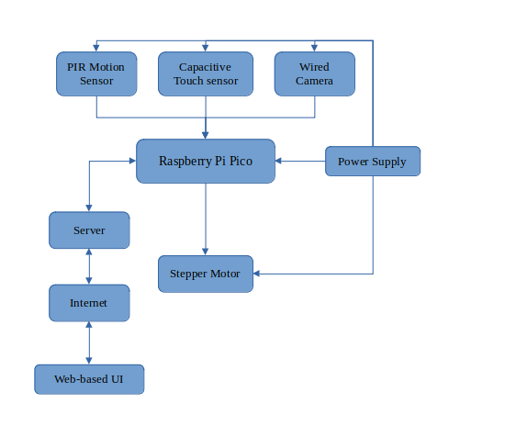***Figure 4.1: System Architecture with different options to be employed.***

**4.3 SEQUENCE DIAGRAM**

Is an interaction diagram that emphasizes time ordering of messages. Focus on the order in which the messages are sent by providing a sequential map of message passing between objects over time.

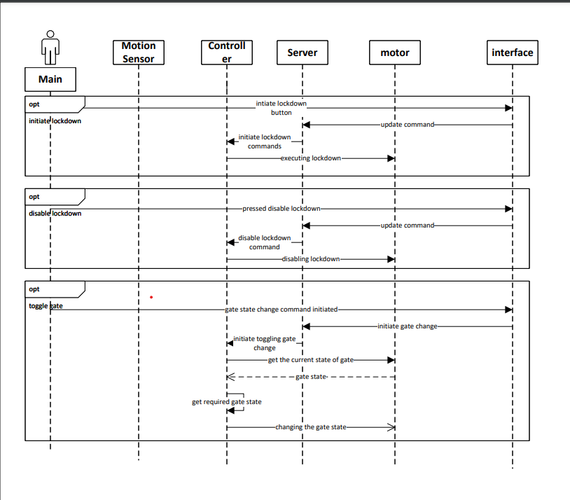***Figure 4.1: System functionality in monitoring and detecting intruders***

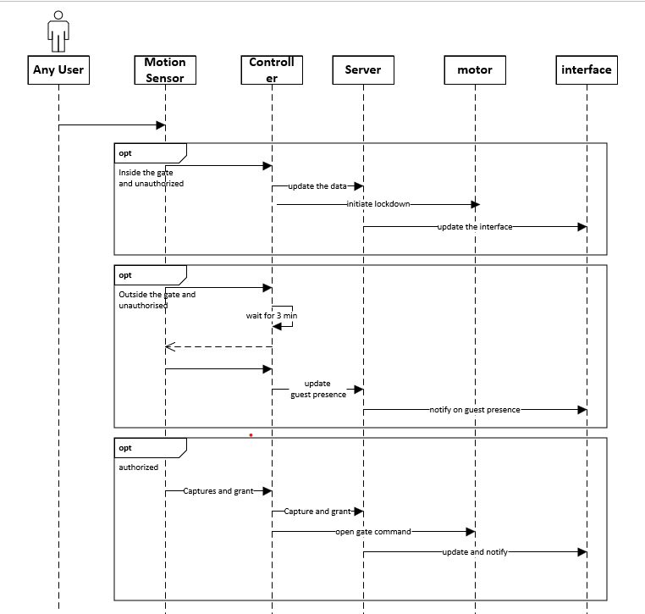***Figure 4.2: Home owner interaction with the system***

**4.4 FINDINGS AND THE PROPOSED MODEL**

From the sequence diagram, analysis shows that:

* Once a person (anyone with inclusive of the user him/her self) is outside and near the gate around the sensing area, the motion detectors trigger the authorization process through camera and image is updated to the user through the user interface.
* The main user can then resolve to two options as either to authorize or not.
* If authorized, the gate command to open the gate can then be initiated by the user.
* If not authorized the system treats a person as a guest until 3 minutes which then treats the person as intruder.
* On the other hand, when the user is inside the gate the user is notified to authorize a person.
* If a person is inside the gate and not authorized by the user or if the system is in automatic mode the system initiates the lockdown process.
* On the user perspective the user can see visual data on the home entrances, enable or disable the lockdown process.
* Also, the user can toggle the gate state and can manually authorize or deauthorize the person.
* The system can also notify the user on presence of individual that enters a safe room or touch the secured safe. If the system is set to automatic mode the system initiates the lockdown automatically unless the user deauthorizes the individual.

**Chapter Five**

**DESIGN IMPLEMENTATION AND SIMULATION**

**5.1 DESIGN IMPLEMENTATION**

Based on the project’s specific objectives, from gathered and analyzed requirements to system design and analysis, the system was implemented accordingly where the functionalities of the system are based only on the achievements of user requirements and engineering requirements.

The functionalities of the System including detection of guest outside the house, intruder break-in in the house as well as a safe room, real time monitoring, sending notifications, were as well as handling actions as requested by the user were carefully implemented using both **PROTEUS IDE** and a simple user interface design.

**5.11 GUEST DETECTION**

* The system will be able to detect activities outside the gate using motion sensors and send information to the home-owner of any activities outside the gate (unauthorized personnel).
* Additionally the system will be able to provide real-time monitoring of home situations via the use of camera and provide a mechanism to open and close a door using a stepper motor when a guest is authorized.

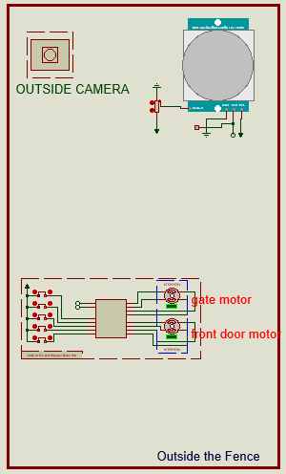***Figure 5.1 Guest Detection implementation in Proteus***

**5.12 INTRUDER DETECTION**

Intruder detection has been divided into two scopes, inside the fence and inside a specific room.

* Inside the fence: Characterized by multiple sensors and cameras surrounding the house to detect the presence of intruders and send immediate alert to the homeowner, along with a real-time picture to assess the situation.
* Inside safe room: Relay motor and a set of sensors are installed at the door trigger an alert signal when someone enters the room or approaches a certain range near a safe.

In both situations, the home owner is promptly notified to take appropriate action based on situation.

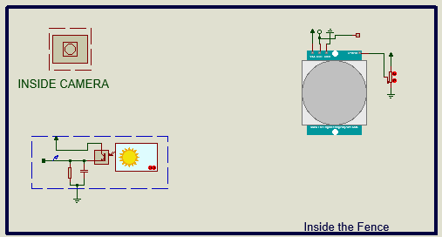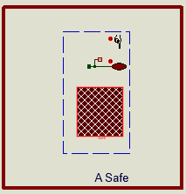***Figure 5.2: Intruder Detection Inside a fence and Safe-room.***

For functionalities of house lock-down, house is equipped with several motors as illustrated *below:*

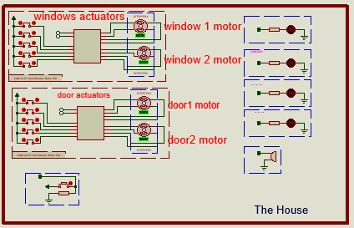***Figure 5.3: The house equipped with different motors.***

**5.13 SIMULATION**

The system was simulated virtually using Proteus IDE. Where the server used was internal server provided by Raspberry Pi micro-controller enabling us to develop a simple interface where a user could interact with the controller and different devices modules.

The simulation was able to provide a message whether there is a guest or an intruder as illustrated:

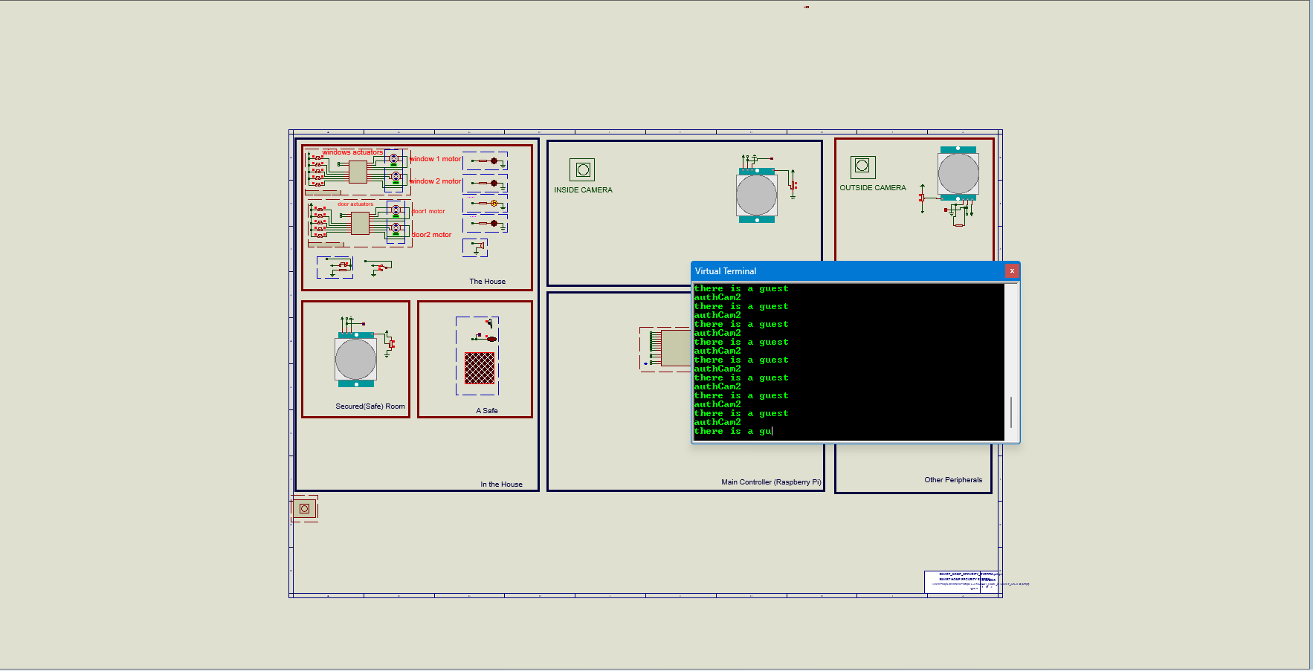***Figure 5.4: Message to imply guest with real time feed at outside camera***

The web application was very simple due to timeline, it was design to meet the requirements to what the user has in terms of monitoring, status of home and action to be performed as illustrated below:

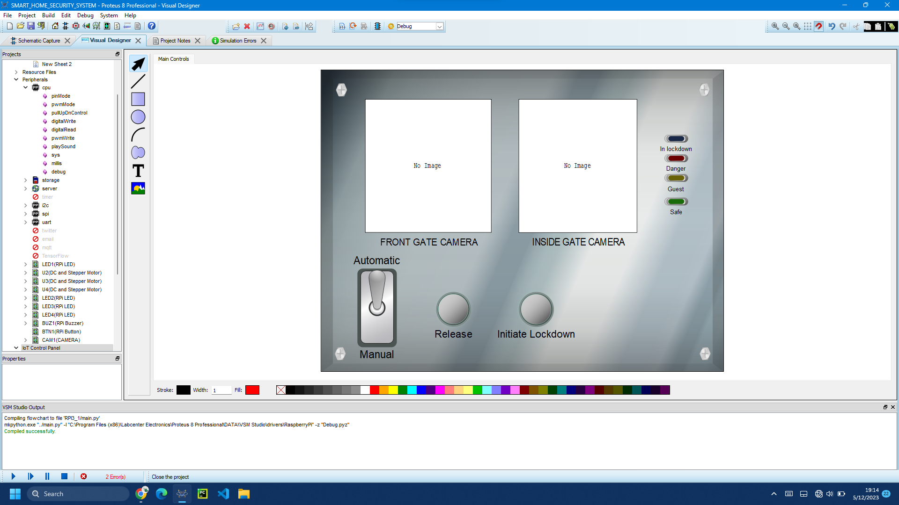***Figure 5.5: User Interface***

**Chapter Six**

**CHALLENGES, RECOMMENDATIONS, AND CONCLUSION**

**6.1 CHALLENGES**

Apart from the successes of this project, the following were the challenges we faced during whole time of the project;

1. Knowledge gap; The project uses technologies that need advanced understanding of the concepts and their implementation. Having no enough knowledge and skills set to use greatly extended project implementation time.
2. Short time implementation; The actual designing of the system and the software requires enough time of development and simulation. Having a short time to do was a great challenge that narrowed the scope and quality of the work done.

**6.2 RECOMMENDATIONS**

Since the main aim of this project is to design an efficient security system in detecting guests and intruders, real-time monitoring home situations, lock-down capabilities with an ease to use interface. The following are recommendations for future project;

1. Mobile application: A mobile application to be used to provide seamless interface for the user to enable multi-platform services.
2. System Security: The future project should focus on security of the system to prevent malicious attacks in both hardware and software.

**6.3 CONCLUSION**

The project has been developed to simulation stage without actual implementation and put into practical, with basic core functionalities have been implemented successfully limited to a scope of house with a fence focusing on improving security of homes.

The improvement of this project should be made in phases, and using the actual coding instead of using visual designs in Proteus.

However for great user experience, the use of application will have impactful potentials in leveraging the capabilities of smart home systems where individuals can effectively monitor and protect their homes against potential intrusions and to take proactive measures and receive timely alerts in the event of any suspicious activities.

# REFERENCES

Faisal Alghayadh, D. D. (2021). Advances in Internet of Things, . *A Hybrid Intrusion Detection System for Smart Home Security Based on Machine Learning and*, 11, 10-25.

M. ShariqSuhaill, G. V. (2016). Multi-functional secured smart home. *International Conference on advances in Computing, Communications and Informatics (ICACCI)*, 2629-2634.

Mohammad Asadul Hoque1, C. D. (2019). International Journal of Networked and Distributed Computing. *Design and Implementation of an IoT-Based Smart Home*, 85–92.

R. Piyare, M. T. (2011). Bluetooth based home automation system using cell phone. *International Symposium on Consumer Electronics (ISCE)*, 192-195.

S. Tanwar, P. P. (2017). An advance internet of thing based security alert system for smart home. *international conference on computer, information and telecommunication systems (CITS)*, 25-29.

P. Netinant, Auttapon Amatyakul, Meennapa Rukhiran (2022). Alert Intruder Detection System Using Passive Infrared Motion Detector based on Internet of Things. *The 5th International Conference on Software Engineering and Information Management (ICSIM)*